Shell Scripting Codes on 27/01/23

1. Remove the duplicates in a file

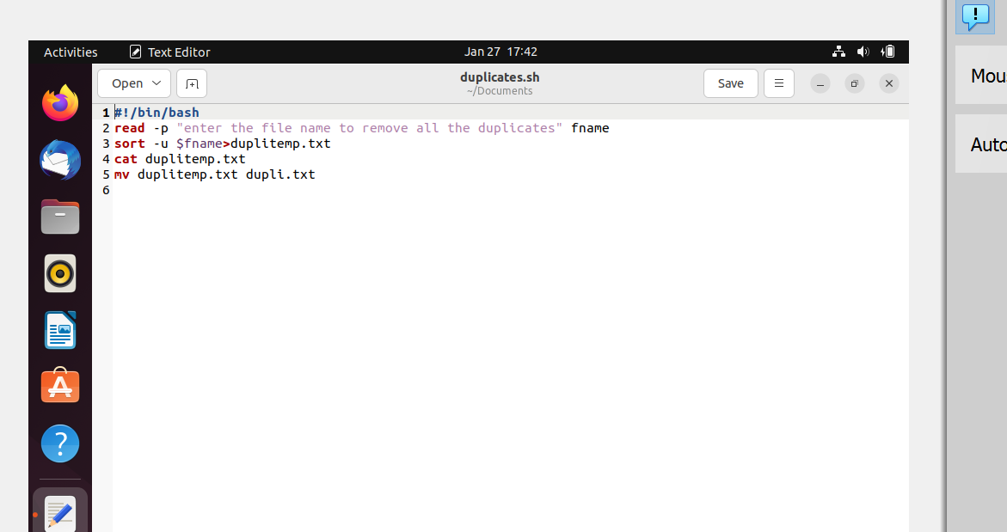

1. Remove Blank Spaces

